Confidential

BSI.IT.10.C19.02 BigFix
BigFix "Permanent Action" that never expires, configured to deploy the CrowdStrike agent to machines within the domain when the agent is not identified. Evidence refreshed November 3, 2026.
Control | BSI.IT.10.C19.02 BigFix
Evidence | BigFix permanent action that deploys the CrowdStrike Falcon sensor to any domain-joined Windows machine where the agent is not detected
Action | 00-126993 !!!...PERMANENT ACTION...!!! - SOFTWARE_DEPLOYMENT_CROWDSTRIKE_WINDOWS_SENSOR
Source | Baseline SOFTWARE_DEPLOYMENT_CROWDSTRIKE_WINDOWS_SENSOR (Master Action Site)
Member actions | 00-126994 Servers (Miami Group), 00-126995 Servers (Virginia Group), 00-126996 Workstations & Laptops
Behavior | Never expires; reapplied as a policy an unlimited number of times whenever a machine becomes relevant; retried up to 5 times
State on evidence date | Open. 100% completed, 25 of 25 applicable computers, 26 reported
Evidence captured | November 3, 2026, 7:44 PM ET, BigFix console on mia-dc-netops, by Roman Francisco
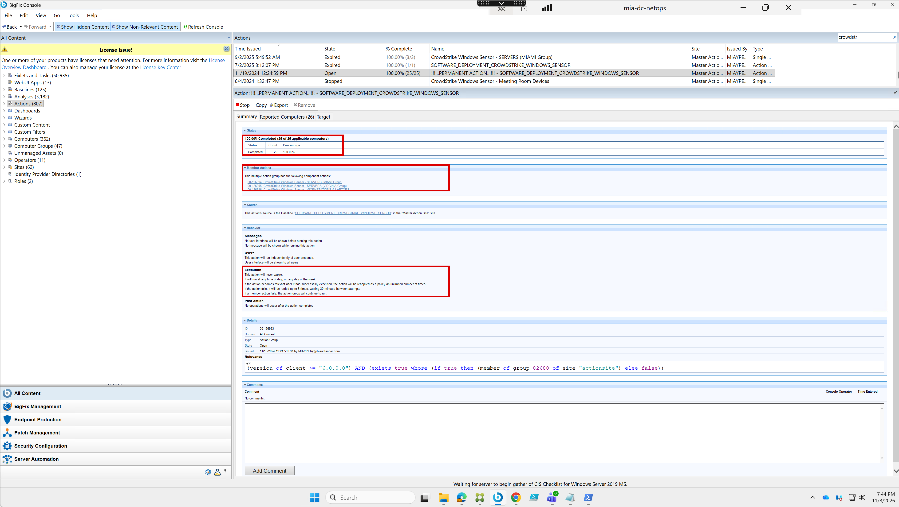
Figure 1. BigFix console, action 00-126993 summary: status, member actions, source, behavior and details. Captured 11/3/2026 7:44 PM.

